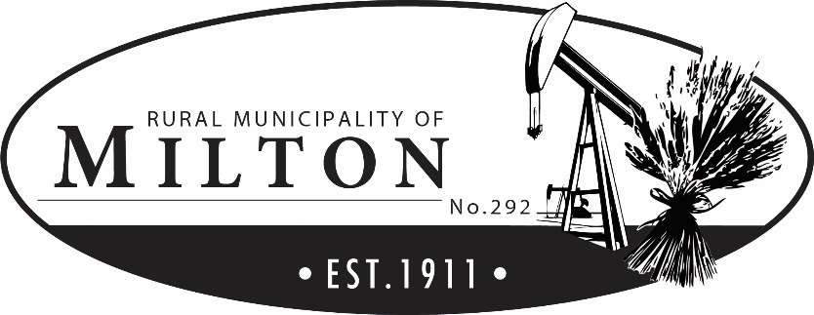
Box 70
Marengo, Saskatchewan
S0L 2K0

(306) 968-2922
(306) 912-8922 fax
rm292.rm322@sasktel.net

Clothing Allowance Policy

Policy Statement
Part VII of The Occupational Health and Safety Regulations, 2020 under The Saskatchewan Employment Act requires an employer to ensure that every worker wears or uses suitable and adequate personal protective equipment. An employer shall provide approved protective equipment to the workers at no cost to the worker.
The Rural Municipality of Milton No. 292 is committed to ensuring that all employees use personal protective equipment to do their job safely.

Purpose
To protect the employees of the Rural Municipality of Milton No. 292 from occupational hazards within the workplace by providing personal protective equipment (PPE).

Application
- Footwear and safety clothing, including CSA approved steel toed boots, are required.

- All road maintenance and public works employees shall be provided by the Rural Municipality of Milton No. 292 the following clothing, which is to be worn while performing municipal duties:
  - Safety Vests
  - Safety Glasses (non-prescription)
  - Gloves
  - Ear Plugs

- The RM of Milton No. 292 will reimburse road maintenance and public works employees for the purchase of CSA approved steel-toed boots and safety clothing up to a maximum of $500.00 every calendar year for year-round employees and $300.00 per calendar year for seasonal employees upon submission of a valid receipt.

- All municipal-issued PPE will conform to OH&S requirements.

- All PPE used will be in good condition and maintained according to the manufacturer’s instructions.

- No piece of PPE will be modified or changed contrary to the manufacturer’s instructions, specifications, or OH&S regulations.

Resolution No. 2023-256
July 10th, 2023

